**HONOURING THE SACRED HEART OF JESUS**

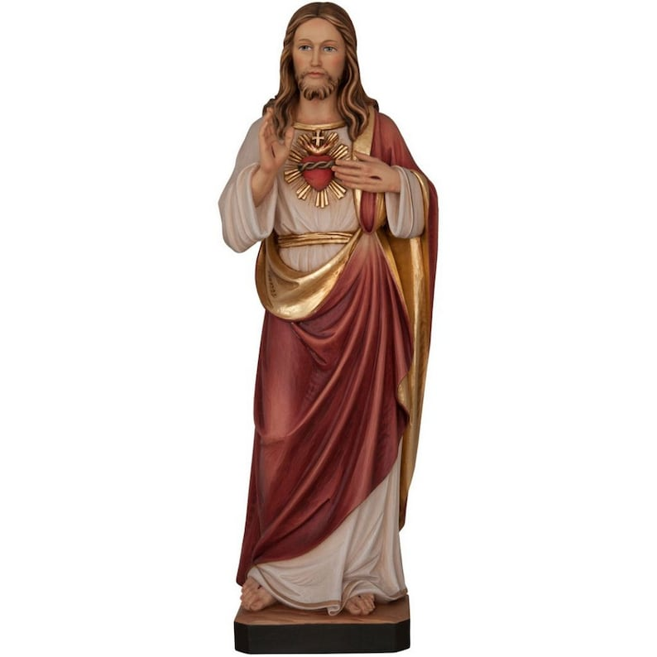

On 8th January last, in St Peter’s Basilica in Rome, Pope Francis blessed four pilgrim statues of the Sacred Heart of Jesus. Over the coming months, the statues will visit cathedrals and parish churches and will include the re-consecration of Ireland to the Sacred Heart of Jesus on Sunday 22nd June in Knock Shrine.

During this Jubilee Year of Hope, we are all encouraged to explore a deeper relationship with the Sacred Heart of Jesus

The Armagh province pilgrim statue will visit the ***Derriaghy-Colin Family of Parishes*** and will be present during Mass on the following dates:

***Friday 13th June*** -Christ the Redeemer Church 6.30pm Mass

***Saturday 14th June -*** Our Lady Queen of Peace Church 11am Mass

***Saturday 14th June -***Saint Luke’s Church 6pm Mass